Level 1 IP3 Support Document

Table of Contents
IP3 Overview 3
Connecting to the IP3 3
Subscriber Administration 4
Add a User 4
Delete a User Account 5
Change a User from a Private IP to a Public IP 5
User Does Not Get Public IP Address after Purchase 6
Verifying Access Codes 7
Verify If the IP3 Has SMTP Redirection 8

IP3 Overview

The IP3 is a stand alone, high performance networking device designed for developing large scale, intelligent Public-access

Connecting to the IP3

To connect to the IP3 with a web browser, the URL is http://<IP address of IP3>. An example would be http://12.159.210.2.

After connecting to the page, you have to login with a username and password. After logging in, you should receive the following screen.

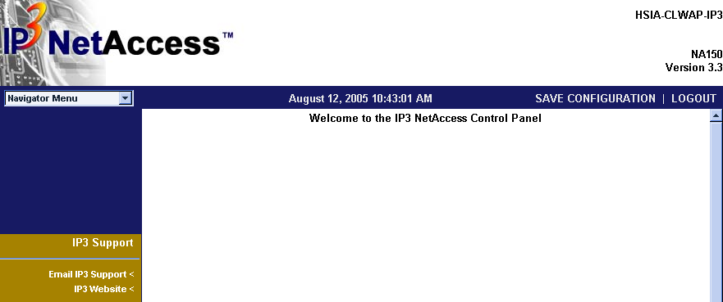

Subscriber Administration

This section allows you to view current subscribers and inactive subscribers.

Add a User

Sometimes you may need to add a user manually to get them connected. I.E. If the user has a VPN client and has to connect to their VPN before they can get to the internet or some Macintosh PCs require you to manually add them.

Select Billing, View All from the left menu. You should receive a screen similar to below:

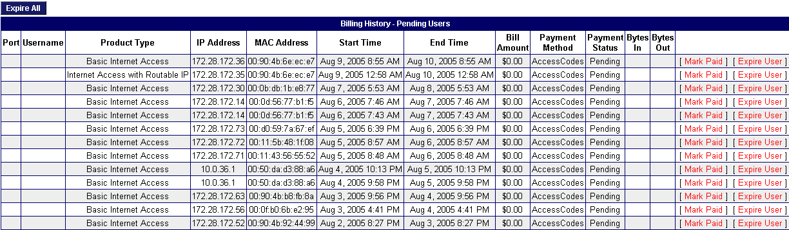

The guest will only show up in the list if they are able to get to the welcome page. If they are having issues logging in you can choose Mark Paid to force them active. If you do not see them under pending or active then you will need to add them to the box as a permit.

To do so go to Advanced Configuration, MAC Filters
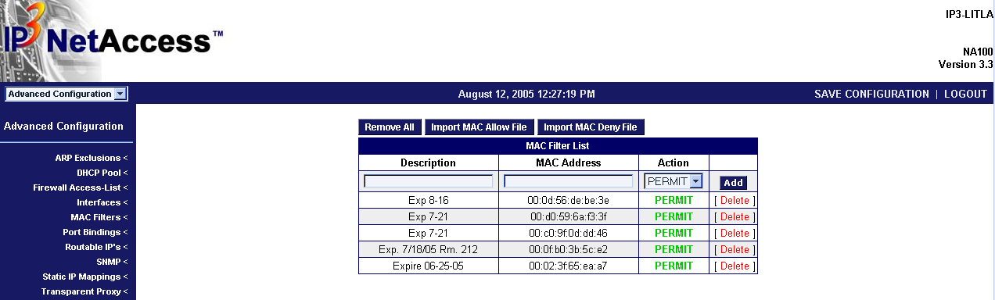
Add their MAC address with a description describing when the guest will be checking out so that the permit can be deleted at a later date. Remember to click the Save Configuration after adding the permit statement or the permit will be lost during a reboot.

Delete a User Account

This section allows you to delete a user’s account permanently.

Select Billing, View All from the left menu. You should receive a screen similar to below:
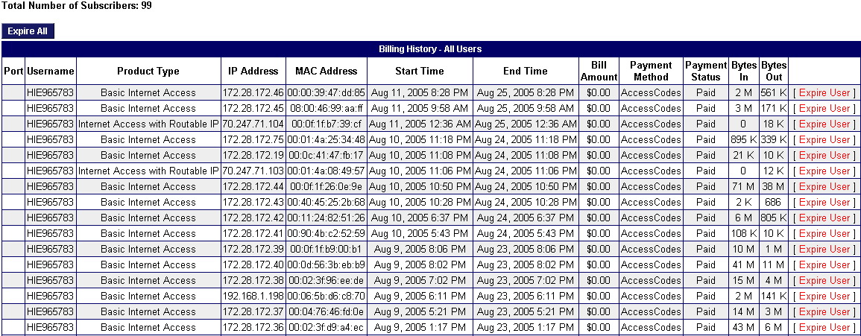
Find the guest based on MAC address and choose Expire User.

To remove completely choose Billing, View Expired. You should receive a screen similar to below:
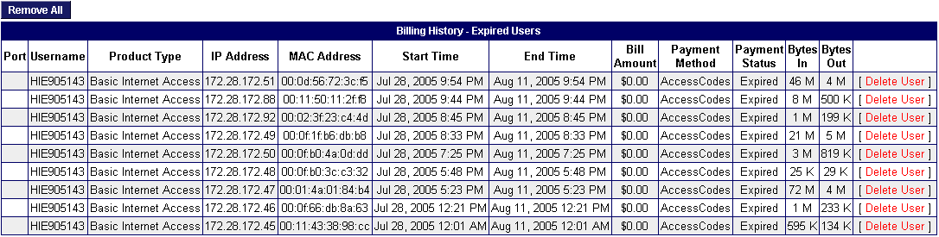
Find the guest based on MAC address and choose Delete User.

Change a User from a Private IP to a Public IP

Follow the directions above to delete the user. Once their account has been deleted have them signup for a public IP address.

User Does Not Get Public IP Address after Purchase

To verify if the public DHCP pool is full, select Advanced Configuration, select Routable IP’s. You should receive a screen similar to below.

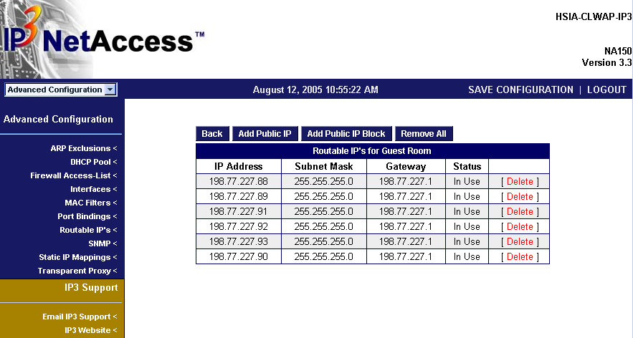

Look in the list of users and see if all the public IP addresses are assigned. If the public DHCP range is full, there is nothing we can do for the guest. The guest will have to wait until an address is available.

Verifying Access Codes

Choose Portal Groups, Billing Options, Authentication Codes
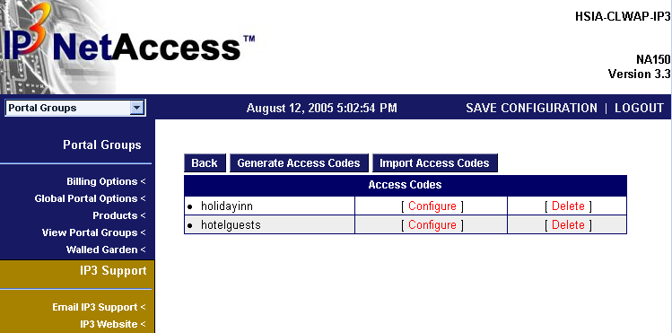

Choose configure for the access code group. There may be multiple access code groups set up. It will give a list of access codes. Verify the code exists in the list of codes.
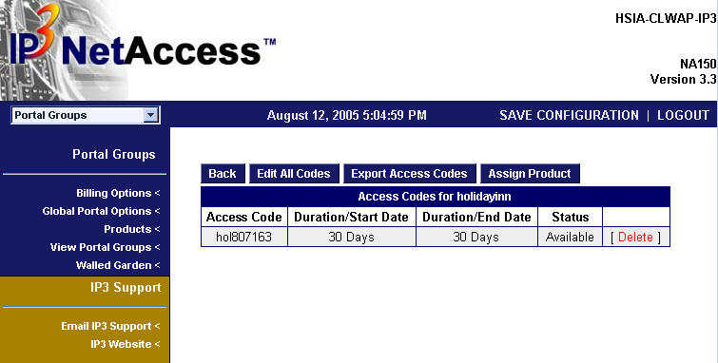
Codes are case sensitive. Verify they are using the correct case and spelling.

Verify If the IP3 Has SMTP Redirection

After connecting to the IP3 via web browser, select Basic Configuration. Under Basic configuration, select Server Options. You should receive a screen similar to below:

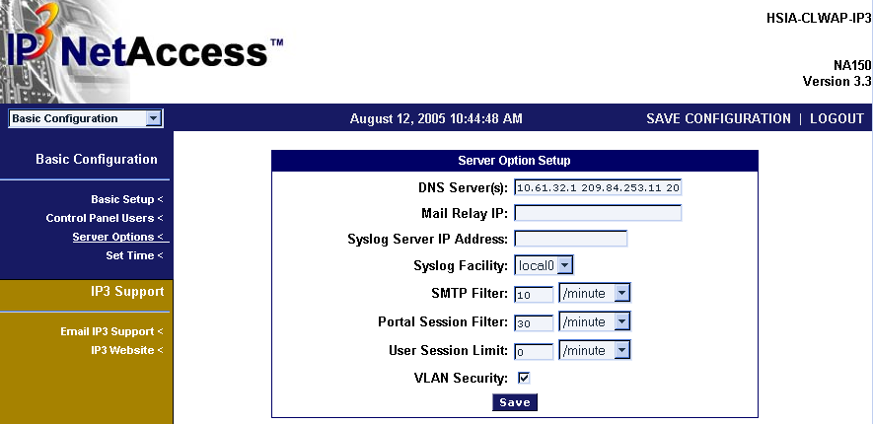

This IP3 is not setup for SMTP redirection. If the Mail Relay IP is blank, then the property does not have a redirection server.

To add a redirection server, simply enter a server into the Mail Relay IP box. Choose Save and then choose Save Configuration in upper right hand corner.

